**Module-3: Docker – I Assignment - 1**

You have been asked to:

● Pull ubuntu container

● Run this container, and map port 80 on the local

● Install apache2 on this container

● Check if you are able to access the apache page on your browser

**Solution:**

1. **Pull ubuntu container** : docker pull ubuntu

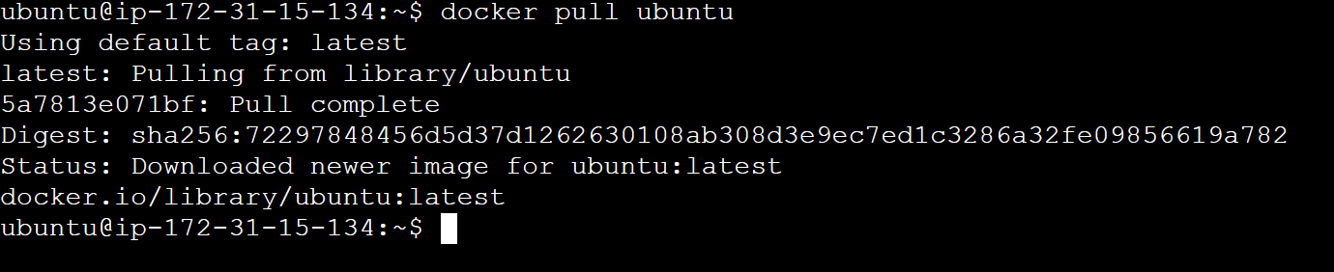

1. **To verify the image is there** : docker images

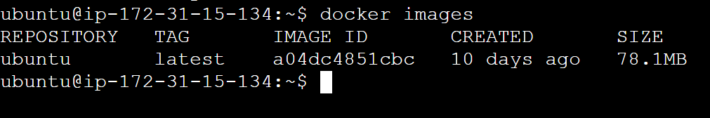

1. **Run this container, and map port 80 on the local** : docker run -dit -p 80:80 ubuntu

Explanation:

**docker run:** This is the command used to create and start a new container.

**-d:** Stands for detached mode. This option runs the container in the background, allowing you to continue using your terminal.

**-i:** Stands for interactive mode. This option keeps the standard input (stdin) open, even if not attached, which is useful for interactive applications.

**-t:** Stands for pseudo-TTY. This option allocates a pseudo-TTY, which gives you an interactive terminal session.

**-p 80:80:** This option maps port 80 on your local machine to port 80 in the container.

ubuntu: This specifies the image to use for the container.



1. **Install apache2 on this container:**
2. list the running containers : docker ps



1. **Attach to the container** : docker exec -it [container_id_or_name] bash



1. **Inside the container, update the package lists**: apt update

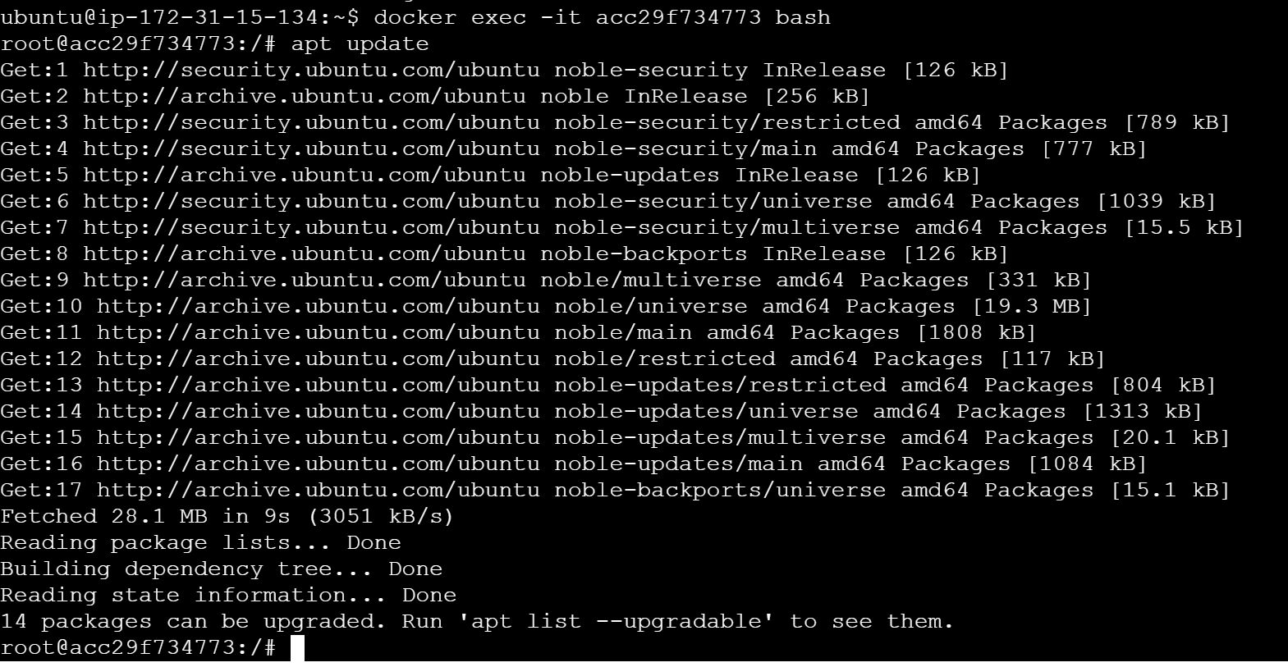

1. **Install Apache2**: apt install apache2 -y

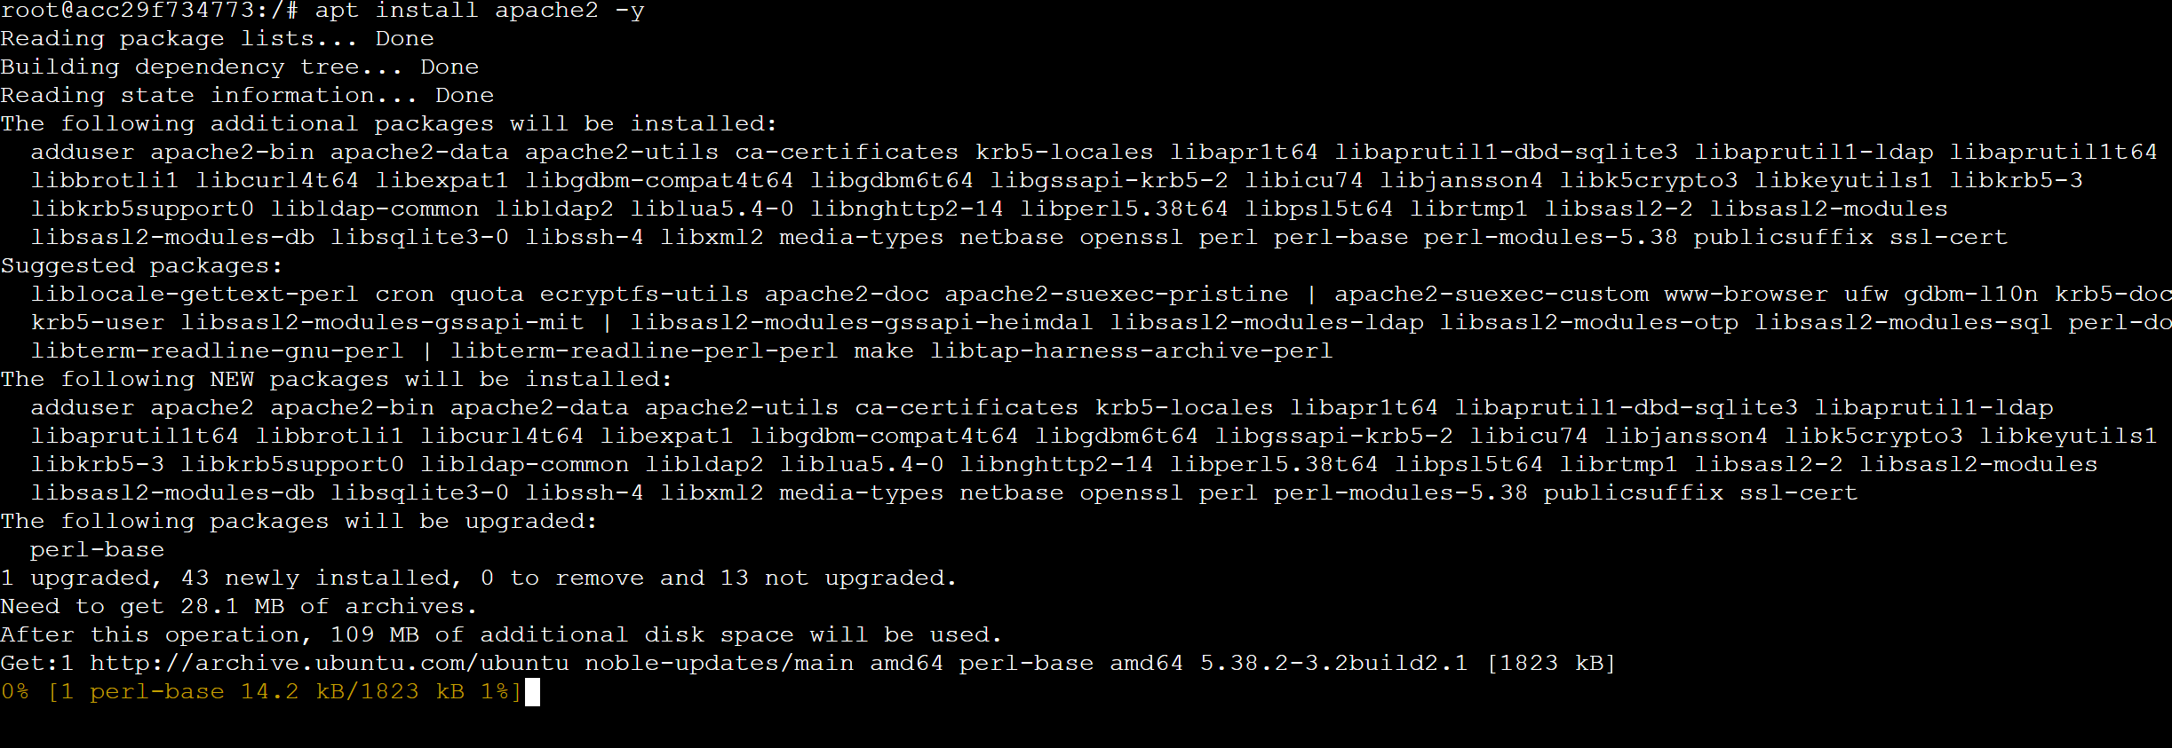

1. **Start the Apache2 Service**: service apache2 start



1. Check if you are able to access the apache page on your browser

Copy the public IP address . navigate to http://<your-server-ip> and we can see the apache default web page.

